Columbia Gorge Windsurfing Association 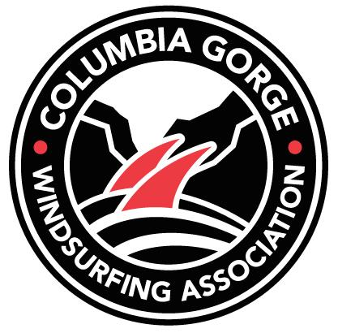

202 Oak St., Suite 150

Hood River, Oregon 97031

Dear Potential Partner,

The Columbia Gorge Windsurfing Association is a 501(c)(3) membership nonprofit in Hood River, Oregon. Founded in 1987, CGWA has worked with our members and partners to create and improve beaches along the Columbia River. Our vision is for an integrated, fully engaged windsurfing community with abundant access to sites and services in support of windsurfing in the Columbia River Gorge.

Our annual fundraising event, “*Beach Bash*,” is coming up on Thursday, June 23rd through Sunday, June 26th. The weekend long event will host food, drinks, live music, and everything the Gorge has to offer! The kids will get to enjoy meeting the pros, windsurfing demos, games and more!

The first day of the event, we are hosting a, ***Pray 4 Wind* Silent Auction**, with all proceeds going to the CGWA kids program. Our kids program gives children the opportunity to windsurf all summer for a low price given the gear from the money raised by donations.

We are also reaching out to your organization in hopes of a donation that will get members engaged in your company and the community, while simultaneously retaining our membership. Our vision is to create a card or coupon book for our members that gives them a variety of discounts in the downtown Hood River area.

**Below are possible options for donations**:

* Donate a gift, giftcard, or other item to be auctioned off at our *Pray 4 Wind Silent Auction,* the weekend of the *Beach Bash Party*
* A discounted item at your store/restaurant to be offered to members the whole year of membership (scan card) **OR** a discounted item/coupon that can be used one time during the membership year (coupon book)

Thank you for your consideration of this event. We look forward to partnering with your company to strengthen our program while simultaneously, increasing your presence throughout the Hood River area and surrounding communities. Any donation is highly appreciated.

Please contact Whylie Massey or Callie Sauer at CGWAInterns@gmail.com or 541-386-9225 with any questions or concerns.

Sincerely,

The CGWA and our Members